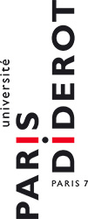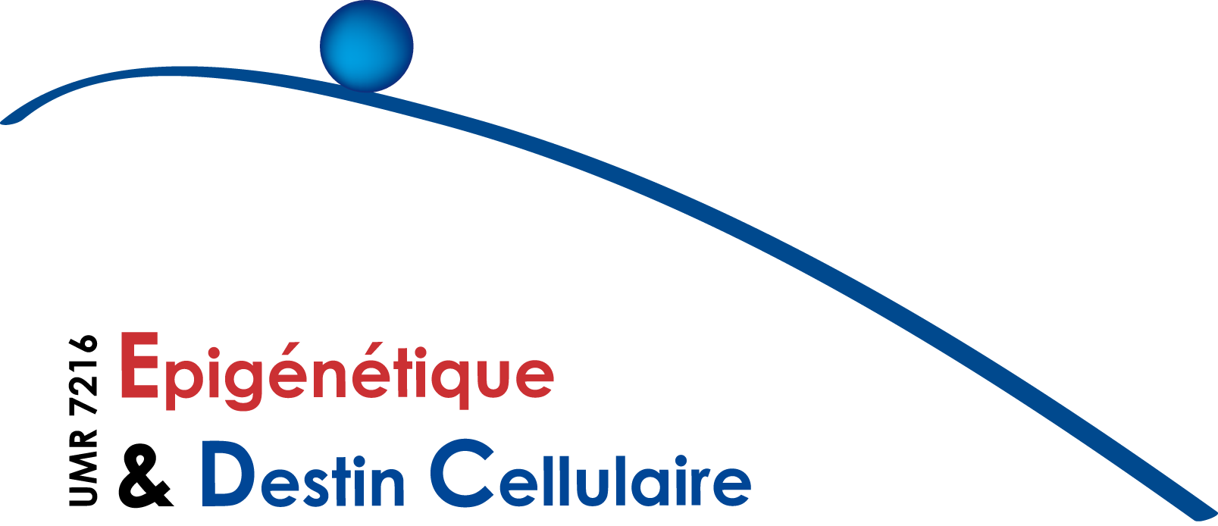

I N F O R M A T I O N S E M I N A I R E E P I G E N E T I Q U E :

April 6th, 2016

Ehud Cohen
The Institute for Medical Research Israel-Canada
The Faculty of Medicine of the Hebrew University of Jerusalem, Israel
Invité par Valérie Mezger
What goes wrong with aging? New insights into the links between Alzheimer’s disease and the aging process
The inhibition of IGF-1 Signaling Promotes Proteostasis by Enhancing Protein Aggregation and Deposition. Lorna Moll, Tziona Ben-Gedalya, Hadas Reuveni and Ehud Cohen (2016). The FASEB Journal. In press.
Alzheimer's Disease-Causing Proline Substitutions Lead to Presenilin 1 Aggregation and Malfunction. Tziona Ben-Gedalya, Lorna Moll, Michal Bejerano-Sagie, Samuel Frere, Wayne A. Cabral, Dinorah Friedmann-Morvinski, Inna Slutsky, Tal Burstyn-Cohen, Joan C. Marini and Ehud Cohen (2015).
The EMBO Journal, 12; 34(22):2820-39.

Differential Regulation of the Heat Shock Factor 1 and DAF-16 by Neuronal nhl-1 in the Nematode C. elegans. Yuli Volovik, Lorna Moll, Filipa Carvalhal Marques, Moria Maman, Michal Bejerano-Sagie and Ehud Cohen (2014). Cell Reports 24; 9(6):2192-205.
A novel inhibitor of the insulin/IGF Signaling pathway protects from age-Onset, neurodegeneration-linked Proteotoxicity. Tayir El-Ami*, Lorna Moll*, Filipa Carvalhal Marques, Yuli Volovik, Hadas Reuveni and Ehud Cohen (2014). Aging Cell 13(1):165-74.
The neuronal GPCR GTR-1 coordinates the heat stress response of the nematode C. elegans.
Moria Maman*, Filipa Carvalhal Marques *, Tatyana Dubnikov, Yuli Volovik , Michal Bejerano-Sagie and Ehud Cohen (2013). The Journal of Neuroscience 3;33(14):6102-11.

Ce séminaire a lieu dans la salle de séminaires de l’Institut Jacques Monod (RB-18B). Bâtiment Buffon - 15 rue Hélène Brion. Paris 13e
Contact : sophie.polo@univ-paris-diderot.fr

Biosketch
Ehud Cohen completed a PhD in cell biology under the direction of Prof. Albert Taraboulos (1998-2004) at the Hebrew University of Jerusalem (Israel). Since one of the common features of neurodegenerative maladies is late onset, he joined the laboratory of Prof. Andrew Dillin at the Salk Institute for biological studies (La Jolla California,2004-2009) where he investigated the links between the biology of aging and the manifestation of neurodegenerative maladies, employing worms and mice. Prof. Ehud Cohen is currently the head of the Laboratory of aging and neurodegenerative diseases at the faculty of Medicine of the Hebrew University of Jerusalem. With his group, he is studying the cellular and molecular mechanisms that govern protein quality control and the biology of aging-regulating pathways, aiming to harness the mechanisms which protect the young organism to prevent the onset of neurodegenerative maladies in late stages of life. His research has been awarded with several scientific prizes and he authored a few articles in prestigious scientific journals.

